

University of Ontario Institute of Technology (UOIT)

Faculty of Engineering and Applied Science (FEAS)

Department Of Electrical, Computer, And Software Engineering (ECSE)

**Operating Systems (SOFE 3950)**

Tutorial #2 Activity | Submission

Yong Deng

Winter 2020

Group Members

Aryan Kukreja (100651838)

Emil Ilnicki (100659072)

Sydney Smith (100654205)

Harasees Singh Gill (100656810)

# Conceptual Questions

## Question 1

The C language is a middle-level language thus it supports low-level programming for things such as scripts for kernels and drivers. In addition, C can be used to write scripts for software applications and utilities making it also support high-level programming languages. The C language is also highly portable for scripting system applications which makes it a major part of Windows, UNIX, and Linux operating systems. Some instances where the C language is used are in embedded systems, operating systems, network drivers, compilers, and databases.

## Question 2

A compiler is a piece of software program that converts computer code written in one language into another target language. Compilers are mainly used for converting high-level programming languages (C, Java, Python) into a lower-level language (assembly). The compiler also automates various tedious tasks such as managing stack frames for subroutines.

## Question 3

Makefile is a simple tool used to simplify the code compilation process. It is especially useful if there are multiple program files that contain inter-related dependencies. It consists of a set of terminal-like commands with variable names and targets for creating or removing object files. We can specify multiple target files to generate within a single Makefile.

The Makefile essentially runs a series of terminal-like commands to define how to compile a set of program files.

## Question 4

1. <stdio.h>, provides file operation support and supplies functions with character input/output capabilities
2. <stdlib.h>, provides general utilities such as memory management, program utilities, string conversions, random number generation
3. <time.h>, provides time and date utilities
4. <arpa/inet.h>, provides the type **in_port_t**, **in_addr_t,** and the structure **in_addr** available for usage. These are all used in client and server setups for TCP and UDP connections
5. <ctype.h>, provides several functions that are used for testing and mapping characters

## Question 5

1. printf(const char *format, ...): Prints a given string to the console output. The string can contain placeholders that can be filled in by supplementary parameters.
2. int atoi (const char * str): Converts a string passed in as a parameter to an integer, and returns it
3. [double difftime(time_t time1, time_t time2)](https://www.tutorialspoint.com/c_standard_library/c_function_difftime.htm): Finds and returns time1 - time2 (the difference)
4. [inet_addr](https://pubs.opengroup.org/onlinepubs/7908799/xns/inet_addr.html)(const char \**cp*): converts a string into an integer value suitable to use as an Internet address
5. islower(int c): It checks if the passed character is a lowercase letter or not.

# Application Questions

## Question 1

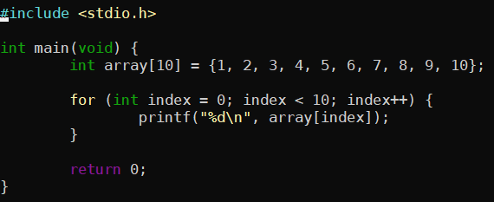

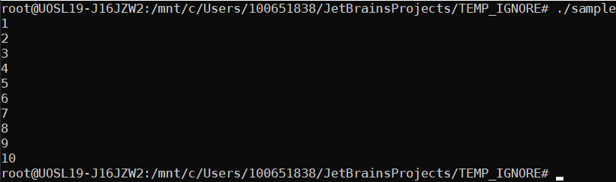

## Question 2

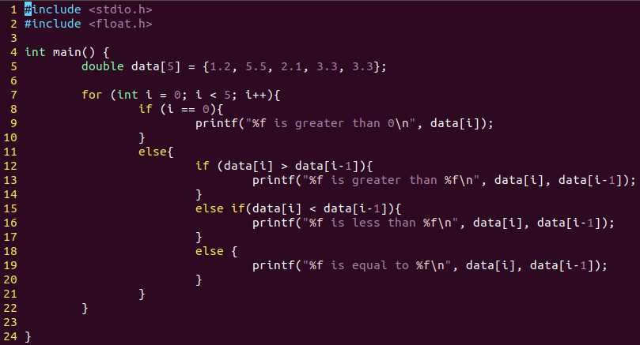

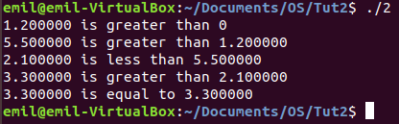

## Question 3

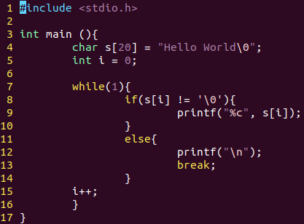



## Question 4

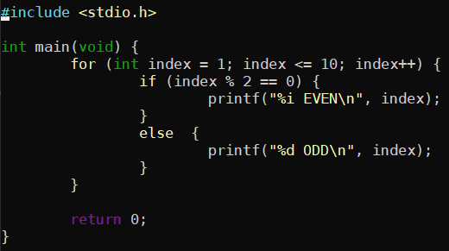

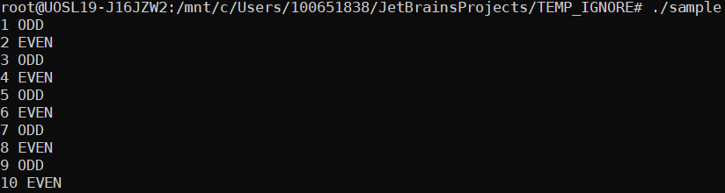

## Question 5

